Doing Household Chores on Vacation

Vacations are often seen as a time to relax, explore, and take a break from daily routines. However, incorporating household chores during vacation can offer surprising benefits. While it may initially seem counterintuitive to work during leisure time, balancing chores with relaxation can lead to a more fulfilling and productive holiday experience.

- Cooking:

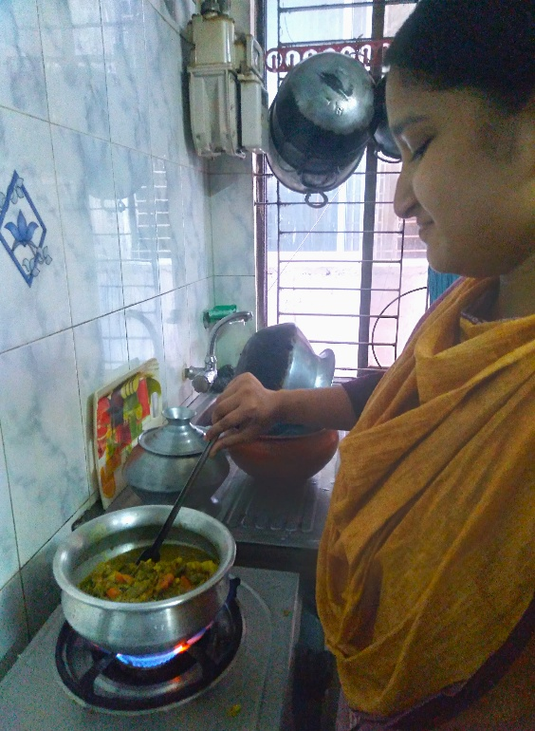

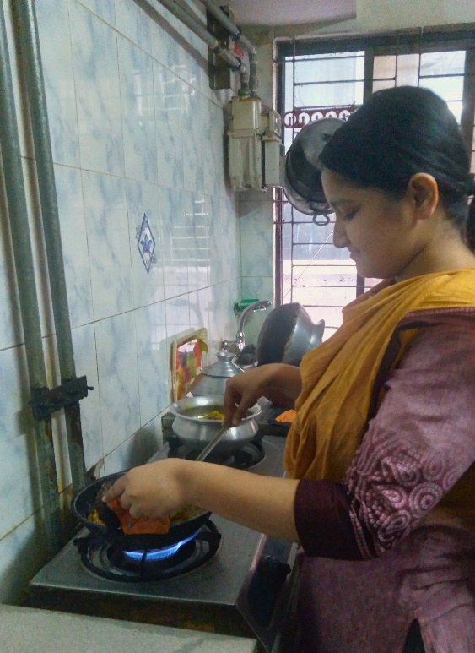

Cooking is a vital chore that requires effort and creativity. During the vacation, I assisted my mother in preparing meals for our family. Each day, I worked alongside my mother to prepare meals that were both healthy and flavorful. For instance, I tried to help in chopping vegetables, measuring ingredients, and stirring dishes while she handled more complex tasks. Through this collaboration, I learned new techniques, such as how to properly season dishes and bake desserts like cakes. The process of working together not only enhanced my cooking skills but also strengthened our bond.

- Washing Dishes:
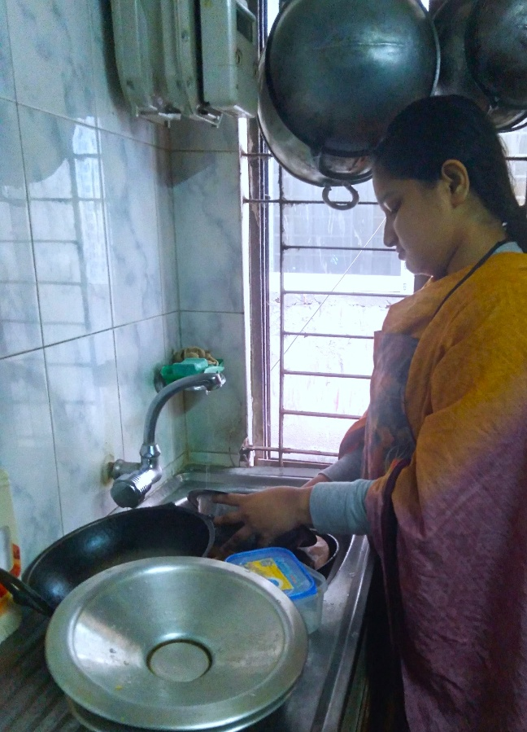
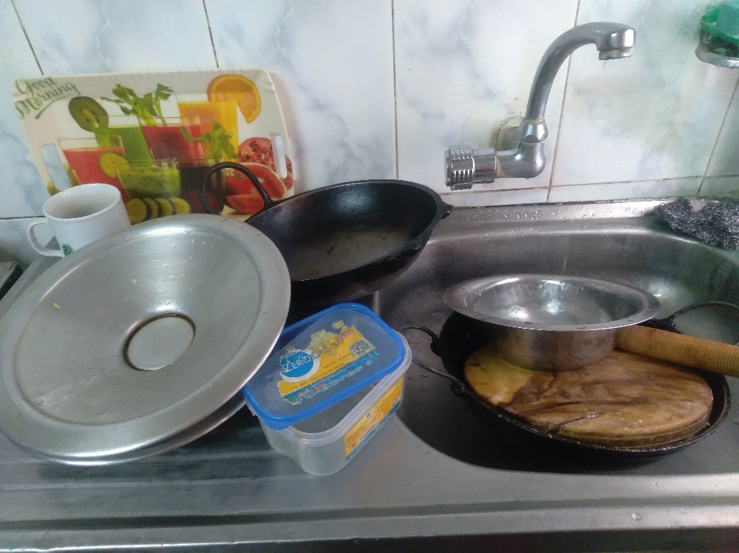

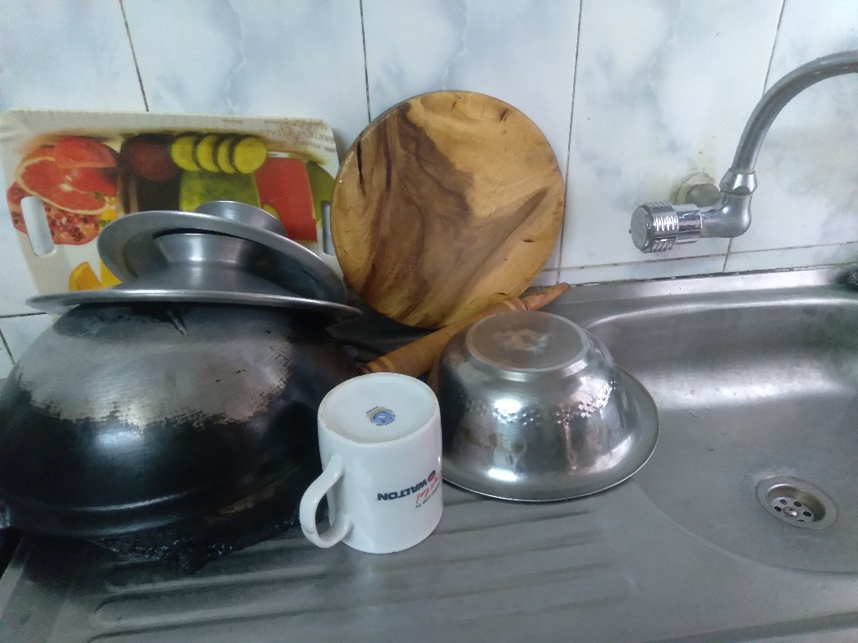

After every meal, I took on the responsibility of washing the dishes. Although it might seem like a straightforward task, it played a crucial role in maintaining a clean and organized kitchen. I started by scraping off food remnants and rinsing the plates, bowls, and utensils. Using warm water and a good-quality dish soap, I carefully scrubbed each item, ensuring that no food residue was left behind. I also made sure to clean the sink and surrounding area to keep the space spotless. To make the chore enjoyable, I listened to my favorite playlist or podcasts while working, which turned it into a relaxing and almost meditative activity.

By assisting my mother with cooking and washing dishes, along with taking on many other tasks such as tidying up the living room, folding laundry, and sweeping the floors, I not only helped ease her workload but also developed valuable life skills and a deeper sense of responsibility. These varied contributions made our vacation more enjoyable for everyone, as they allowed us to share the workload and spend more quality time together. Helping with household chores during vacation is a simple yet effective way to show care and support for family members.

